# Running Solr in Apache Tomcat

1. Download and extract Solr 4.9.0 .zip from Apache Solr [archive](http://archive.apache.org/dist/lucene/solr/) website in SOLR INSTALLATION directory, say C:\Program Files\solr-4.9.0.
2. Download and install latest Java JDK 8 or 7 (Minimum above 1.7 update 55) from [Oracle Java SE](http://www.oracle.com/technetwork/java/javase/downloads/index-jsp-138363.html) site. The install instructions and compatibility remain the same for both the versions.
3. Create JAVA_HOME environment variable pointing to the Java home directory. For example, on my command prompt, the following command gives,  
   echo %JAVA_HOME%  
   C:\Program Files\Java\jdk1.7.0_67
4. Download and extract latest Apache [Tomcat 7](http://tomcat.apache.org/download-70.cgi) (7.0.55) OR [Tomcat 8](http://tomcat.apache.org/download-80.cgi) (8.0.12) .zip files. The install instructions and compatibility remain the same for both the versions.

Create CATALINA_HOME environment variable with path to your apache-tomcat-extracted-folder. For example, on my command prompt,   
echo %CATALINA_HOME%

D:\apache-tomcat-7.0.55

1. Create a folder anywhere in your drive for solr web application base directory. Give this directory path for CATALINA_BASE environment variable.  
   For example, on my command prompt,

echo %CATALINA_BASE%

R:\Solr

1. Create a Solr home directory anywhere locally. For example:   
   R:\Solr\solrhome   
   This directory will be referred to as SOLR_HOME. This directory will contain all your solr configurations.
2. Create the following folder structure in your CATALINA_BASE

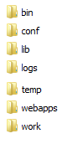

1. Copy CATALINA_HOME/conf contents in CATALINA_BASE/conf
2. Create CATALINA_BASE/conf/Catalina/localhost directories and add following conf file with the contents as shown below:



<?xml version="1.0" encoding="UTF-8" ?>

<Context docBase="R:\Solr\solr-4.9.0.war" debug="0" crossContext="true" >

<Environment name="solr/home" type="java.lang.String" value="R:\Solr\new\solrhome4.9.0" override="true" />

</Context>

The **docBase** is path to your war file found in your   
<SOLR INSTALLATION directory>/dist/solr-4.9.0.war  
 The Environment tag “solr/home” is the path to your SOLR_HOME

1. Copy the logging jars found in <SOLR INSTALLATION directory>/example/lib/ext/*.jar into your CATALINA_BASE/lib
2. Download [ojdbc jar](http://www.oracle.com/technetwork/apps-tech/jdbc-10201-088211.html) into CATALINA_BASE/lib  
   Sample jar attached.



The jars in CATALINA_BASE/lib should look like this

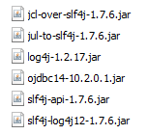

1. Sample SOLR_HOME directory for solr 4.9.0 is attached here. You may copy the contents of the following extract as your SOLR_HOME



The configuration changes that need to be done in the above zip extract in your environment is as follows:

* Edit <SOLR_HOME>/solr.xml with your Solr instance server and port (default is localhost: 8080)  
  This file also contains the names of your Solr Cores. (default <core> is db-core) You will see separate folders in SOLR_HOME for each core. Each core will have its own Solr configuration.
* Edit <SOLR_HOME>/<core>/db-data-config.xml with your database connection settings
* Edit <SOLR_HOME>/<core>/conf/dataimport.properties with your Solr instance server IP, port (if changed), Solr Core name (if changed), webapp name (if changed).

1. Copy the following jars found in your <SOLR INSTALLATION directory> into <SOLR_HOME>/lib

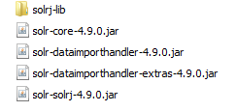

1. Start Tomcat server by running <CATALINA_HOME>/bin/startup.bat
2. Point your browser to

http://localhost:8080/solr-4.9.0

1. Select your core in the drop down in the left side:

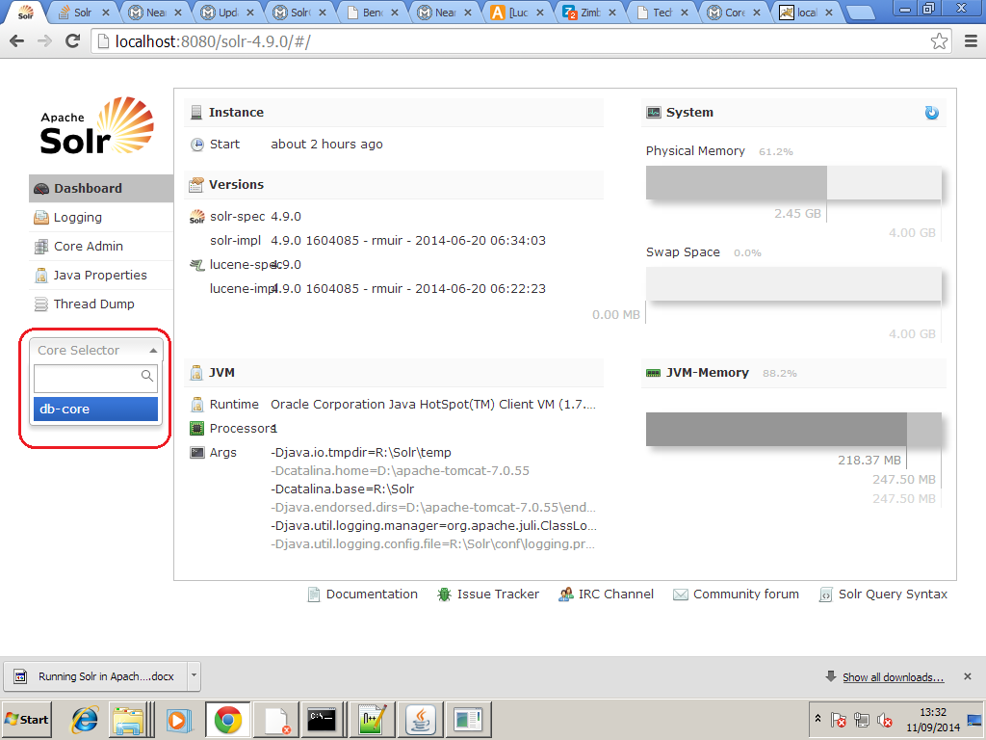

1. Import data for indexing by selecting DataImport of the left menu and then selecting ENTITIES as given below:

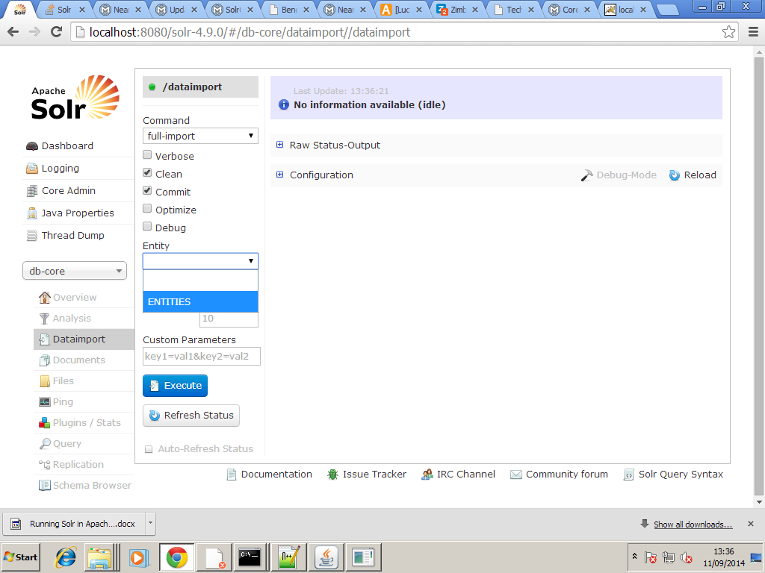

1. After 15 seconds, query for data by selecting Query in the left menu as follows:

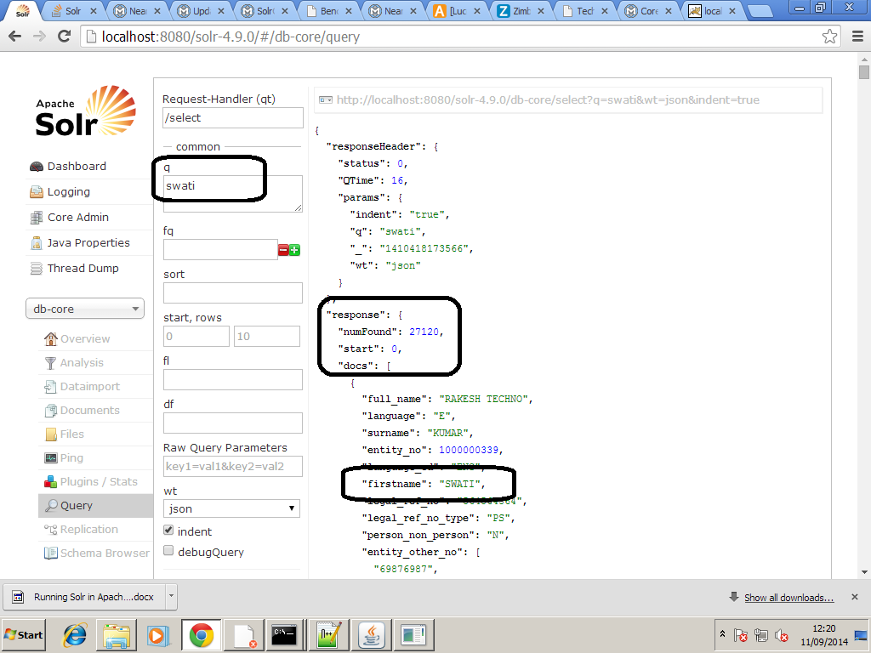

1. Happy Searching!